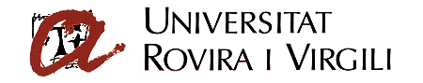PUBLIC COMPETITION FOR THE AWARDING OF PREDOCTORAL RESEARCH GRANTS OF THE ROVIRA I VIRGILI UNIVERSITY

DECLARATION OF CESSION OF RIGHTS

I, ____________________________________, of ______________ nationality and with NIE ___________________, resident at __________________________, and acting on my own behalf

DECLARE:

1. That I am a predoctoral research fellow (reference _____________________) of the __________________________________ department and will carry out research activities at the Rovira i Virgili University (URV) using the facilities of that University and under the supervision of its teachers and research staff.

2. That I understand the URV regulations on industrial and intellectual property passed by agreement of the Governing Council on the 30 October 2009. I therefore expressly accept these regulations, agree to the contents therein, and recognise that the ownership and administration of the research results obtained while I am a predoctoral fellow of the Department of _________________________________ or that are obtained as a consequence of this research belong to the URV whatever the form in which or the place at which they are presented and whatever the form of intellectual or industrial property, patents included.

3. That I must immediately inform the URV in writing and via the director or supervisor of my thesis of any work or invention resulting from my research tasks that may be subject to intellectual or industrial property law.

4. That I understand my right to be considered author (or inventor) of the above work, and any other rights derived from my condition as author or inventor.

5. That I will sign all the necessary documents to protect the intellectual or industrial property rights resulting from my research work in any country.

6. That I will keep the results of my research work confidential until I am expressly authorised in writing by the person in charge of the research project or by his or her replacement.

(Signature)

Tarragona, _____ _______________ 201__

