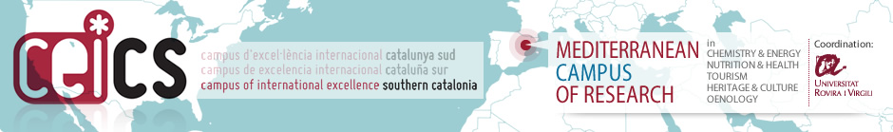

LETTER OF SUPPORT ⁽¹⁾

⁽¹⁾ To be filled in by the host research group. The supporting form should show clearly that the host research group has a strong interest in the specific candidate. Only one supporting form will be accepted per candidate.

R&D group from Universitat Rovira i Virgili
Name of the group
Surname and name of the RC ⁽²⁾:
Surname and name of the URV Head Department

⁽²⁾ RC: Researcher in charge of the R&D group

Details of the proposed candidate
Surname and name
NIF / NIE / Passport

State briefly the reasons for the group’s interest in the proposed candidate

By signing this form, the host research group expresses its interest in the research line carried out and its willingness to host the candidate, if selected, under the conditions specified in the call for applications.

Signature of the researcher in charge of the URV R&D group | Signature of the URV Head Department

,

